| BERT | model1 | model 2 | model3 |  |
| --- | --- | --- | --- | --- |
| 数据 | nlp | no nlp | no nlp |  |
| max len | 80 | 60 | 60 |  |
| batch size | 32 | 32 | 32 |  |
| dropout | 0.3 | 0.3 | 0.5 |  |
| epoch | 5 | 10 | 10 |  |
| lr | 2e-5 | 2e-5 | 2e-5 |  |
| train acc | 0.7758715668529158 | 0.9189295244074713 | 0.9200282530215036 |  |
| train loss | 0.47602926434284476 | 0.1659063121448633 | 0.16653837488945528 |  |
| val acc | 0.7197732997481108 | 0.7380653266331658 | 0.7223618090452262 |  |
| val loss | 0.5742246317863464 | 1.1173113811016082 | 1.204080491065979 |  |
| test acc | 0.7067337948395218 | 0.7490589711417817 | 0.7327478042659974 |  |
| test loss | 0.5541509002447128 | 0.600092266201973 | 0.5105617612600326 |  |

BERT MODEL 2

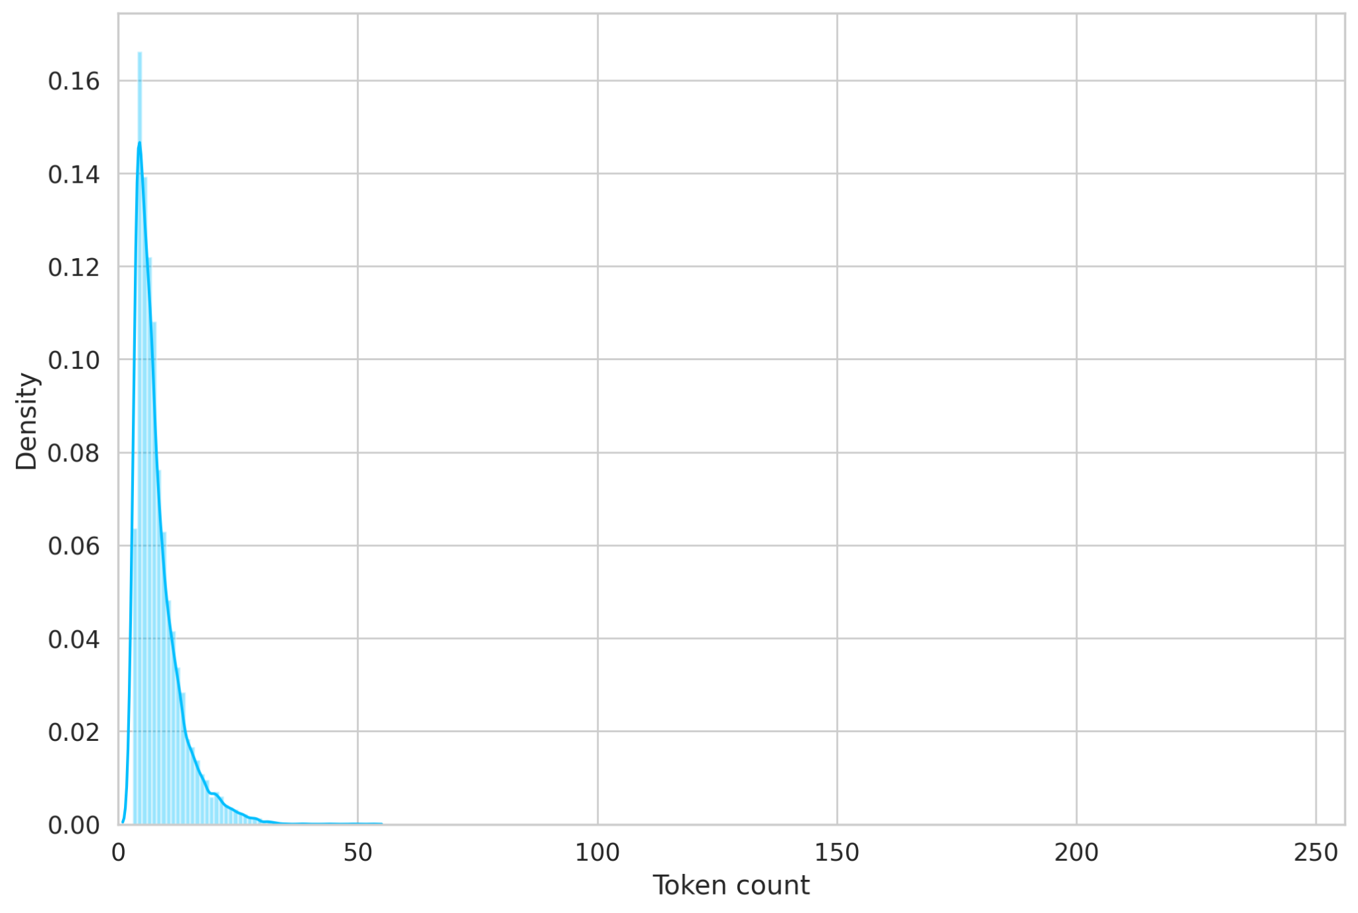

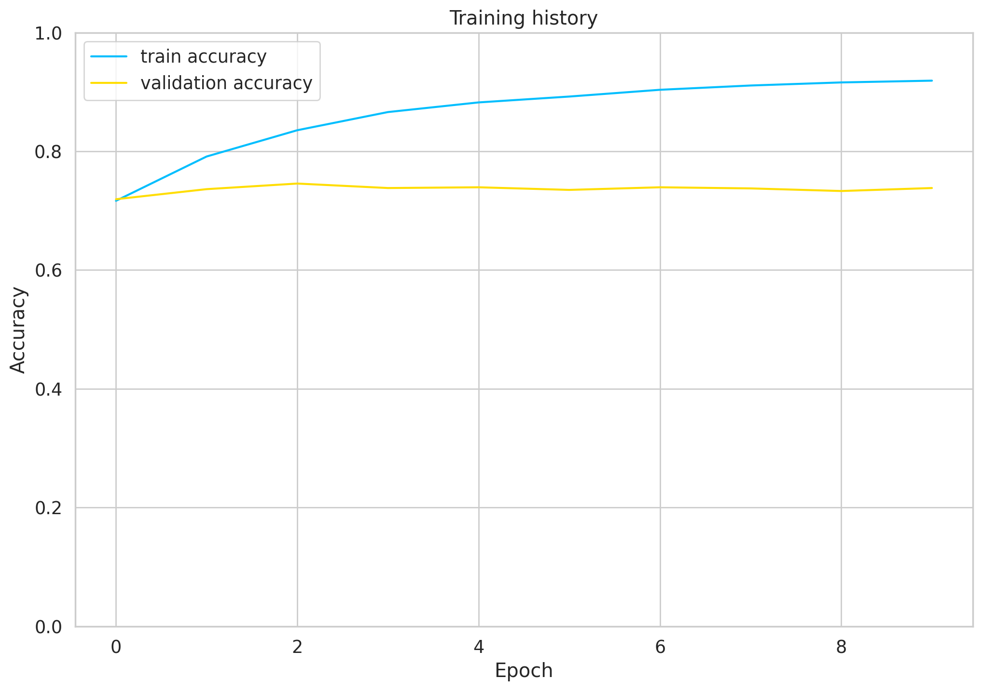

precision recall f1-score support

negative 0.74 0.68 0.71 827

positive 0.68 0.73 0.71 762

accuracy 0.71 1589

macro avg 0.71 0.71 0.71 1589

weighted avg 0.71 0.71 0.71 1589

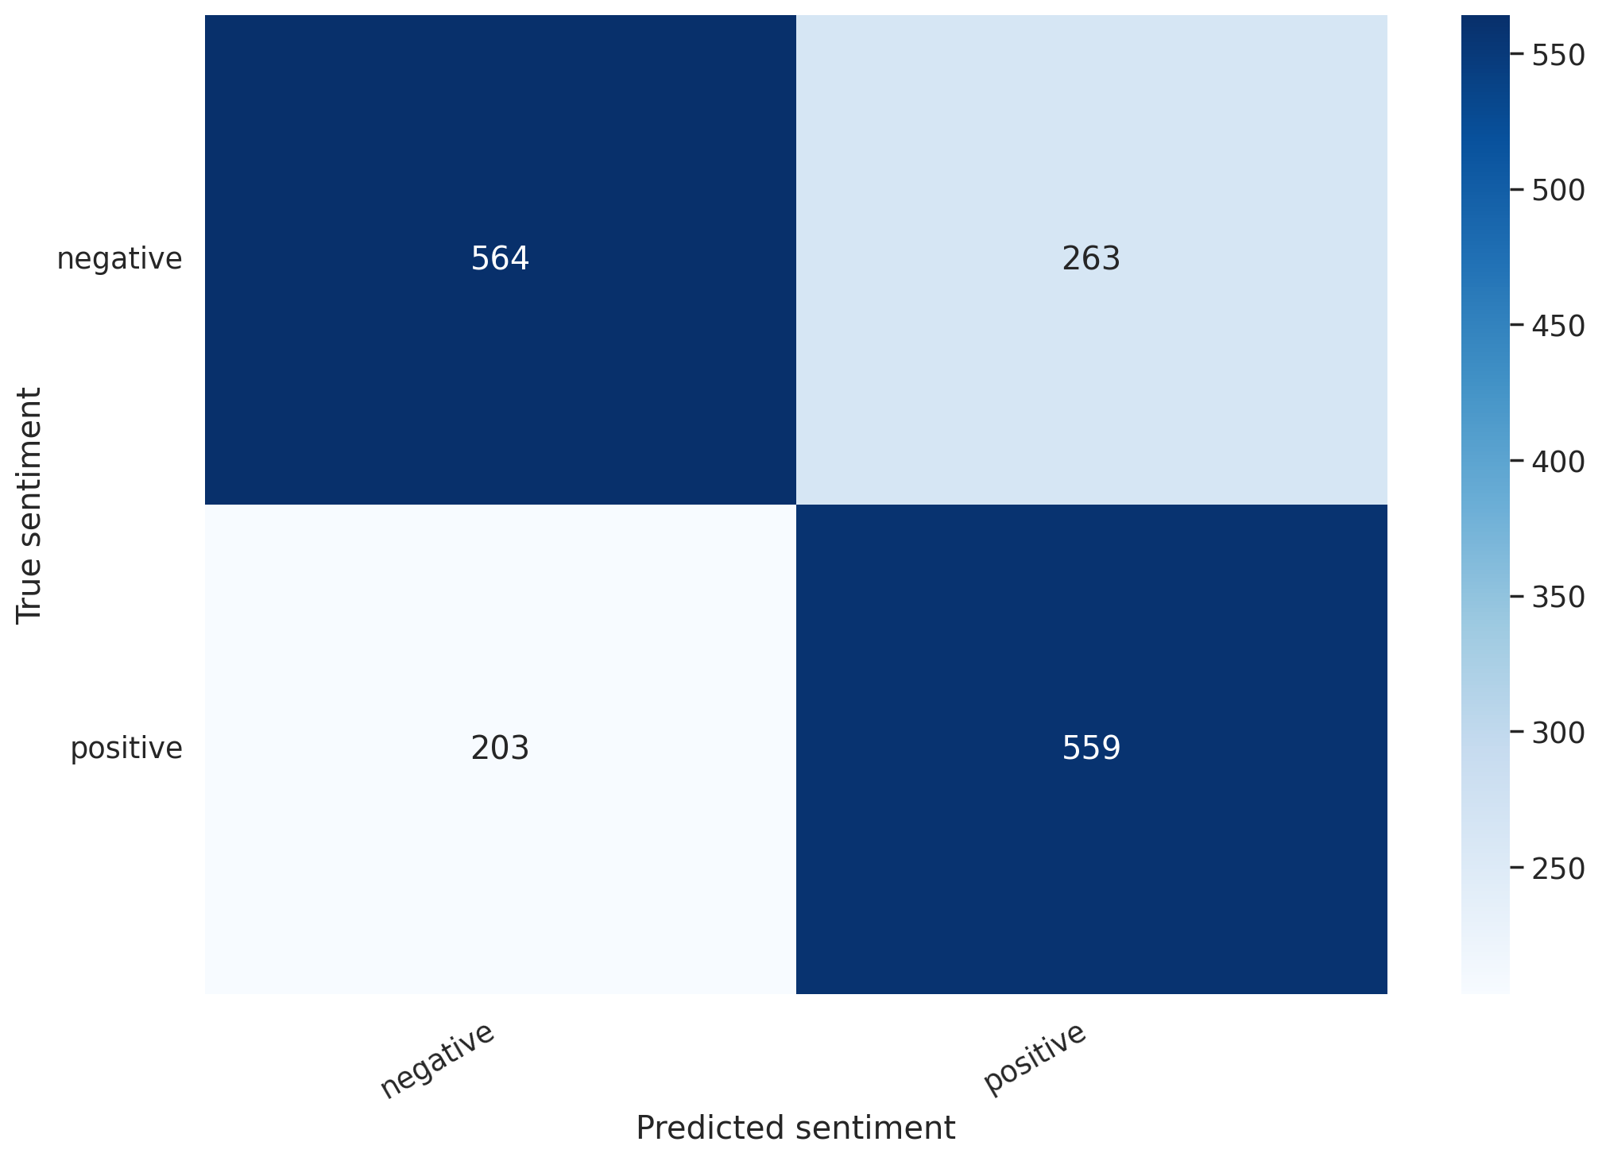

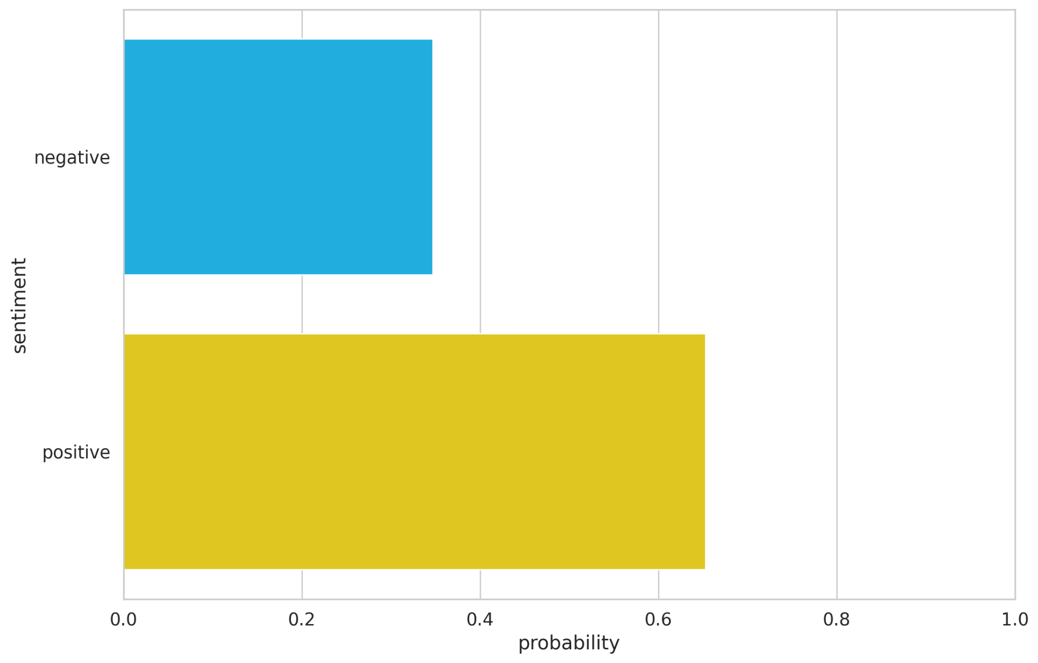

| CNN | model1 | model 2 | model3 | model4 | model5 |
| --- | --- | --- | --- | --- | --- |
| 数据 | processed | processed | processed | processed | processed |
| early stopping criteria | 5 | 5 | 5 | 5 | 5 |
| batch size | 128 | 128 | 128 | 128 | 200 |
| seed | 1337 | 1337 | 1500 | 1337 | 1337 |
| epoch | 30 | 30 | 30 | 50 | 30 |
| lr | 0.001 | 0.01 | 0.001 | 0.001 | 0.001 |
| train acc | 0.8270991161616162 | 0.888809974747475 | 0.8441445707070707 | 0.8912563131313131 | 0.8911111111111111 |
| train loss | 0.40043032741305823 | 0.26876912439110306 | 0.37369325877440085 | 0.265138519382236 | 0.26993846869657917 |
| val acc | 0.7089843750000001 | 0.6874999999999999 | 0.7109375 | 0.6868489583333333 | 0.6857142857142857 |
| val loss | 0.5791598111391068 | 0.7285695374011993 | 0.5833957890669506 | 0.7281286219755808 | 0.6990311912127903 |
| test acc | 0.7266 | 0.7044 | 0.7031 | 0.7044 | 0.7000 |
| test loss | 0.559 | 0.656 | 0.574 | 0.664 | 0.658 |

| GRU | model1 | model 2 | model3 | model4 |
| --- | --- | --- | --- | --- |
| 数据 | processed | processed | processed | processed |
| bidirectional | False | False | False | False |
| batch size | 64 | 64 | 100 | 100 |
| seed | 1337 | 1337 | 1337 | 1337 |
| epoch | 30 | 30 | 30 | 50 |
| lr | 1e-3 | 0.01 | 1e-3 | 1e-3 |
| train acc | 0.7496054292929296 | 0.6429924242424242 | 0.7431496062992122 | 0.7855905511811024 |
| train loss | 0.4949559765030639 | 0.6276097854580546 | 0.5046559506513939 | 0.4330320921469861 |
| val acc | 0.681640625 | 0.609375 | 0.682 | 0.6746666666666668 |
| val loss | 0.6334540024399757 | 0.641700009504954 | 0.622689797480901 | 0.6892610053221384 |
| test acc | 0.6699 | 0.6081 | 0.6780 | 0.6700 |
| test loss | 1.400 | 0.644 | 1.325 | 1.851 |

| GPT2 | model1 | model 2 | model3 |  |
| --- | --- | --- | --- | --- |
| 数据 | no nlp |  |  |  |
| max len | 60 |  |  |  |
| batch size | 32 |  |  |  |
| dropout |  |  |  |  |
| epoch | 10 |  |  |  |
| lr | 1e-5 |  |  |  |
| train acc | 0.713 |  |  |  |
| train loss | 0.551 |  |  |  |
| val acc | 0.707 |  |  |  |
| val loss | 0.562 |  |  |  |
| test acc |  |  |  |  |
| test loss |  |  |  |  |

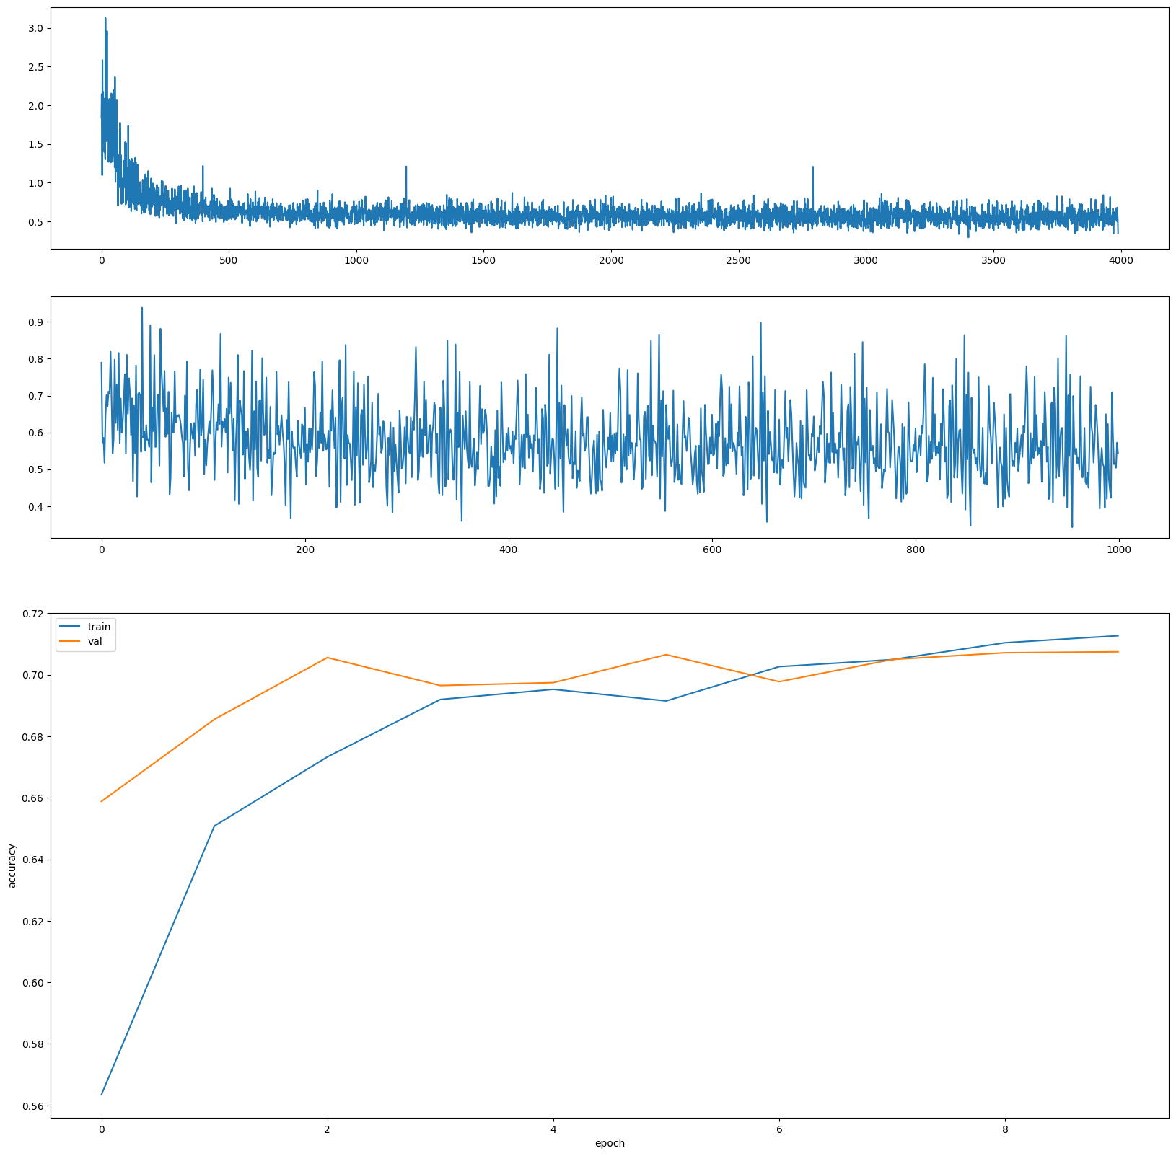

| RoBERTa | model1 | model 2 | model3 |  |
| --- | --- | --- | --- | --- |
| 数据 | no nlp |  |  |  |
| max len | 60 |  |  |  |
| batch size | 32 |  |  |  |
| dropout | 0.5 |  |  |  |
| epoch | 10 |  |  |  |
| lr | 1e-5 |  |  |  |
| train acc | 0.5053 |  |  |  |
| train loss | 0.6932 |  |  |  |
| val acc | 0.5167 |  |  |  |
| val loss | 0.6930 |  |  |  |
| test acc |  |  |  |  |
| test loss |  |  |  |  |

| RNN | model1 | model2 | model3 | model4 | model5 |
| --- | --- | --- | --- | --- | --- |
| 数据 | processed | processed | processed | raw | raw |
| mode | max | max | mean | max | mean |
| max len | 60 | 100 | 150 | 100 | 100 |
| batch size | 32 | 64 | 128 | 64 | 32 |
| dropout | 0.0 | 0.3 | 0.2 | 0.3 | 0.5 |
| epoch | 14 | 13 | 13 | 15 | 15 |
| lr | 3e-3 | 1e-3 | 0.01 | 1e-5 | 1e-3 |
| bidirectional | True | False | False | False | True |
| train acc | 70.9 | 70.3 | 66.8 | 54.9 | 74.4 |
| train loss | 0.563 | 0.565 | 0.599 | 0.69 | 0.511 |
| val acc | 68.3 | 68.5 | 69.3 | 61.3 | 70.4 |
| val loss | 0.583 | 0.59 | 0.612 | 0.667 | 0.546 |
| test acc | 68.2617 | 68.4560 | 66.4063 | 63.4766 | 70.1531 |
| test loss | 0.5970 | 0.5799 | 0.6084 | 0.6672 | 0.5613 |

| LSTM | model1 | model2 | model3 | model4 | model5 |
| --- | --- | --- | --- | --- | --- |
| 数据 | processed | processed | processed | raw | raw |
| mode | mean | mean | max | max | mean |
| max len | 150 | 50 | 100 | 100 | 100 |
| batch size | 128 | 32 | 128 | 128 | 64 |
| dropout | 0.2 | 0.3 | 0.5 | 0.5 | 0.3 |
| epoch | 12 | 14 | 15 | 15 | 16 |
| lr | 0.01 | 1e-3 | 1e-4 | 1e-4 | 1e-5 |
| bidirectional | False | True | True | True | True |
| train acc | 70.8 | 71.9 | 69.2 | 71.2 | 59.5 |
| train loss | 0.553 | 0.547 | 0.582 | 0.549 | 0.66 |
| val acc | 68.6 | 69 | 69.4 | 69.7 | 63.1 |
| val loss | 0.594 | 0.583 | 0.58 | 0.562 | 0.64 |
| test acc | 67.0900 | 65.7227 | 67.3828 | 69.1406 | 64.5182 |
| test loss | 0.588 | 0.5906 | 0.5926 | 0.5612 | 0.6438 |